Sujit Malde, ela17sm (Prof. Martin Foster) Electronic and Electrical Engineering, The University of Sheffield

3rd Year Project Initialisation Document

“Exploring and Combining different Motional Feedback Techniques for a Loudspeaker”

**Project Description**

The requirements of a loudspeaker as stated by E. R. Hanson [1] are: to be as small as possible, respond as linearly and across as much of the frequency spectrum as possible, to distort minimally, and to consume and emit power efficiently. These aims are almost never completely realised due to nearly all loudspeakers outside of experimental settings not exhibiting any form of feedback mechanisms. The subwoofer is the worst offender in this category; since such large masses of air must be moved to produce low frequencies, the requirements become even more difficult to meet, and poor performance under the 70Hz range [2] is coupled with non-linear and non-ideal performance in the passband. The aim of this project is to explore methods of collecting one or many feedback signals from one or many parameters of a subwoofer and feed them into the input to the voice coil to try and achieve superior sound quality, i.e. more response below 70Hz and linearity, without the expense usually required to purchase open-loop systems that can do so.

**Background Theory**

1. Loudspeaker Circuit and System Block Diagram

A loudspeaker may be modelled as two circuits, which interact through a magnetic field. The electrical circuit is simply the voice coil’s resistance *RE* and inductance *LE*. The mechanical circuit is derived through dimensional analysis, which equates the mechanical properties of the mass of the cone and air, the spring property of the suspension, and the total mechanical damping effects as an equivalent inductance *LM*, capacitance *CM*, and resistance *RM* respectively [3]. As shown in Fig. 1 [4], these two circuits are linked by a transformer that represents the back-emf/force constant, *Bl*. The critical relationship of proportionality between force on the cone and current through the coil allows a full system block diagram for a loudspeaker to be derived, as shown by Fig. 2 [5,6]. The system analyses conducted by [5] and [6] models the loudspeaker as two systems. For an input voltage *Vin(s),* the electrical impedance produces an output current *I(s)* as described by the transfer function

(1)

where *R*, *L* are the resistance, inductance of the voice coil respectively. The coupling effect of the back-emf/force constant) transfers *I(s)* to the equivalent mechanical impedance as an equivalent force. The velocity of the cone *v(s)* as a result of this force *F(s)* is described by the transfer function

(2)

where *k*, *m*, *b* are the stiffness, mass, and damping coefficient of the loudspeaker respectively. *b* = *Kf* + *Zrad* where *Kf*, *Zrad* are the friction and radiation impedance respectively. The velocity of the cone *v(s)* generates a force opposing *F(s),* which induces a back-emf *E(s)* through *Bl*. *E(s)* acts against *Vin(s)*.

Fig. 1 Loudspeaker electrical and equivalent mechanical circuit

1. State variable feedback

As can been seen from Fig. 2, the loudspeaker is a single-input single-output (SISO) system. However, there are other potential system outputs that would be valid signals to feed back to the control circuit, such as the current in the voice coil, and some states that cannot be measured directly and thus require the measurement of other parameters to obtain, such as the cone velocity. Thus, the technique of state variable feedback [7] becomes useful for this project. State variable feedback allows different feedback signals to be collected and mixed together, which increases the accuracy of control of the loudspeaker, since there are both electrical and mechanical effects to consider.

1. Obtaining feedback signals

The system block diagram shown in Fig. 2 shows that the cone’s velocity is fed back into a controller, but velocity is not a directly measurable property. The electromechanical parameters described earlier must be measured and velocity mathematically derived, or the control loop mathematics adjusted to accept a different parameter as feedback. Some methods of doing so are presented in [5]; the author designs and implements a method using a varactor (variable capacitor) as a displacement sensor. The varactor, as part of a Clapp oscillator, is placed onto the loudspeaker’s cone, and varies in capacitance with the excursion of the cone, generating a frequency-modulated value for displacement of the cone. This varies the frequency of oscillation of the Clapp oscillator, therefore, when, the Clapp oscillator’s output is compared with that of a phase-locked loop circuit [8], the raw displacement measurement is obtained, and a differentiator converts this into the velocity of cone.

The work in [9] describes an accelerometer attached to the cone measuring acceleration, specifically, the details of the effect of the accelerometer on the loudspeaker’s performance. The effect of the varactor on the loudspeaker’s performance was not evaluated in [5] – for any control system that will be implemented, its effect on performance must be evaluated, in order to ensure that all work against non-linearity isn’t being undone by the same equipment that is being used.

The work in [6] describes a method of controlling the loudspeaker current by using a disturbance observer estimator. Disturbance is random, therefore cannot be calculated and must be estimated; the generated estimated error signal is fed forward and subtracted from the output to ensure that any noise or unwanted external signals are removed from the output of the loudspeaker. It would be wise to implement uncertainty estimation along with disturbance estimation, since the mechanical properties of the loudspeaker will change over time. This allows linearity to be achieved not just in ideal laboratory conditions, but in real-world conditions with real-world usage.

1. Enclosure design

Manufacturers of loudspeakers do not quote the equivalent electromechanical circuit parameters shown above and in Fig. 1 because it is difficult to measure them directly. Instead, some parameters that describe the low-frequency performance of the loudspeaker are provided; these are known as the Thiele-Small parameters [10]. When designing the enclosure for a loudspeaker, it is vital to know its Thiele-Small parameters to ensure that the full range of electrical and mechanical effects are considered and accounted for, such that sound performance is as optimal as possible given the requirements for the enclosure. The work conducted by S. Linkwitz as summarised in [11] demonstrates the process of designing an enclosure that is sufficiently small for a reasonable output. This process is necessary to ensure that the introduction of any control system does not unnecessarily increase the size of otherwise cheap and compact loudspeakers. The size of the enclosure defines the loudspeaker’s maximum excursion, so when designed properly, the loudspeaker cannot ever distort by travelling too far, so it is important that the mechanical building stages are afforded as much care and attention as the electrical design and build stages.

**Project Specification**

* Theorise, predict, and simulate open-loop loudspeaker behaviour and frequency responses, based on actual subwoofer device parameters.
* Explore different methods of collecting feedback from loudspeaker output and devise a system that combines as many as possible
* Design and manufacture subwoofer enclosure.
* Design and manufacture control circuits (analogue implementation circuits as minimum, digitally if possible within time).
* Compare performance of subwoofer with and without feedback enabled, and with no feedback systems present in the enclosure at all.
* Qualitatively assess the performance of the finished closed-loop system against a reference high-performance open-loop system.

**Project Schedule**

Fig. 3 is a Gantt chart

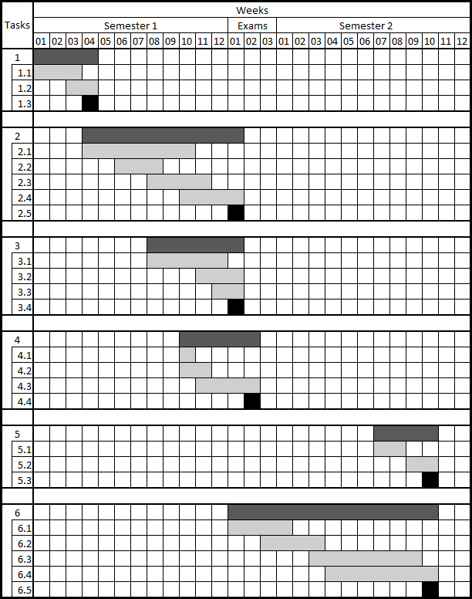

Fig. 3 Project Gantt chart

|  |  |  |
| --- | --- | --- |
| **Tasks** | | **Description** |
|  | **Sub-tasks** |  |
| *1* |  | *Project Initialisation Document* |
|  | 1.1 | Initial research |
|  | 1.2 | Write-up |
|  | 1.3 | Hand-in |
| *2* |  | *Interim Report* |
|  | 2.1 | Simulation and build of open-loop system plus Linkwitz filter |
|  | 2.2 | Simulations of closed-loop system |
|  | 2.3 | Design and build of different closed-loop circuits |
|  | 2.4 | Report writing |
|  | 2.5 | Hand-in |
| *3* |  | *Second marker viva* |
|  | 3.1 | Collation of understanding and milestones |
|  | 3.2 | Slide preparation |
|  | 3.3 | Practice and refinement |
|  | 3.4 | Presentation |
| *4* |  | *Public engagement video* |
|  | 4.1 | Choosing a target audience |
|  | 4.2 | Storyboarding |
|  | 4.3 | Filming / animating and editing |
|  | 4.4 | Hand-in |
| *5* |  | *Symposium* |
|  | 5.1 | Adaptation and updating of viva slides |
|  | 5.2 | Practice and refinement |
|  | 5.3 | Presentations |
| *6* |  | *IEEE Article* |
|  | 6.1 | Further research and design using real parameters |
|  | 6.2 | Parts purchase and building |
|  | 6.3 | Troubleshooting, testing, validating |
|  | 6.4 | Report writing |
|  | 6.5 | Hand-in |

Fig. 4 Project Gantt chart key

+

–

Fig. 2 Loudspeaker system diagram with coil current as the output

**Risk Register**

|  |  |  |  |  |  |  |  |
| --- | --- | --- | --- | --- | --- | --- | --- |
| **Risk** | **Scoring** | | | **Reducing the risk** | **New scoring** | | |
| **Severity** | **Likelihood** | **Risk Factor** | **New Severity** | **New Likelihood** | **New Risk Factor** |
| Losing all project files due to computer hardware failure or carelessness with removable storage. | 5 | 3 | 15 | Version control using git, keep local copies of legacy repositories on home computer / laptop / university computer. | 3 | 1 | 3 |
| Running out of time | 3 | 3 | 9 | Strict adherence to Gantt chart (external factors allowing) should keep progress on-track at all times. | 3 | 2 | 6 |
| Over-spending | 3 | 4 | 12 | Purchasing through approved project budget acts as a deterrent against bad purchases but does not stop it completely. Purchase double of all required circuit board materials in case of damage to a prototype board. | 2 | 2 | 4 |
| Health and safety complications | 4 | 2 | 8 | Read, view, and absorb all health and safety related material delivered to undergraduates. Conduct health and safety training. | 4 | 1 | 4 |
| Excessive time without supervisor contact | 3 | 2 | 6 | Set the standard for weekly meetings and regular email communication early on in the project. Report to Kean Boon Lee if necessary. Individual nature of project allows for some complete autonomy if necessary. | 2 | 1 | 2 |
|  |  |  |  |  |  |  |  |

**Bibliography**

1. On the Design of Some Feedback Circuits for Loudspeakers
2. Design and Evaluation of Accelerometer based Motional Feedback
3. E. R. Hanson, “A motional feedback loudspeaker system," in *Audio Engineering Society Convention 46,* Audio Engineering Society, 1973.
4. Control of Loudspeakers Using Disturbance-Observer-Type Velocity Estimation
5. S. A. Lane and R. L. Clark, “Improving loudspeaker performance for active noise control applications,” *J. Audio Eng. Soc.*, vol. 46, pp. 508–519, 1998.
6. ~~W. Klippel, “Direct feedback linearization of nonlinear loudspeaker systems,”~~ *~~Journal of the Audio Engineering Society,~~* ~~vol. 46, no. 6, pp. 499-507, 1998.~~
7. H. F. Olson, *Elements of* *Acoustical Engineering,* New York: D. Van Nostrand Company, Inc. 1940.
8. F. Rumsey and R. McCormick, *Sound and Recording,* 5th ed. Oxford: Focal Press, 2006.
9. F. X. Y. Gao and W. M. Snelgrove, "Adaptive linearization of a loudspeaker," *[Proceedings] ICASSP 91: 1991 International Conference on Acoustics, Speech, and Signal Processing,* Toronto, Ontario, Canada, 1991, pp. 3589-3592 vol.5.
10. P. Horowitz and W. Hill, *The Art of Electronics,* 3rd ed. New York: Cambridge University Press, 2015.
11. M. Golnaraghi and B. Kuo, *Automatic Control Systems,* 10th ed. McGraw-Hill. (ISBN is 978-1-25-964383-5)
12. “Loudspeakers in a vented box”
13. S. Linkwitz, "Subwoofer estimates", Linkwitzlab.com. [Online]. Available: https://www.linkwitzlab.com/thor-estim.htm. [Accessed: 22- Oct- 2019].
14. E. R. Hanson, “A motional feedback loudspeaker system,” in *Audio Engineering Society Convention 46,* Audio Engineering Society, 1973.
15. F. Rumsey and R. McCormick, *Sound and Recording,* 5th ed. Oxford: Focal Press, 2006.
16. H. F. Olson, *Elements of* *Acoustical Engineering,* New York: D. Van Nostrand Company, Inc. 1940.
17. F. X. Y. Gao and W. M. Snelgrove, "Adaptive linearization of a loudspeaker," *[Proceedings] ICASSP 91: 1991 International Conference on Acoustics, Speech, and Signal Processing,* Toronto, Ontario, Canada, 1991, pp. 3589-3592 vol.5.
18. J. Catrysse, “On the Design of Some Feedback Circuits for Loudspeakers,” in *Audio Engineering Society Volume 33,* Audio Engineering Society, 1985.
19. Yaoyu Li and G. T. -. Chiu, "Control of Loudspeakers Using Disturbance-Observer-Type Velocity Estimation," in *IEEE/ASME Transactions on Mechatronics*, vol. 10, no. 1, pp. 111-117, Feb. 2005.
20. M. Golnaraghi and B. Kuo, *Automatic Control Systems,* Tenth Edition, 10th ed. New York: McGraw-Hill Education, 2017.
21. P. Horowitz and W. Hill, *The Art of Electronics,* 3rd ed. New York: Cambridge University Press, 2015.
22. Design and Evaluation of Accelerometer based Motional Feedback
23. “Loudspeakers in a vented box”
24. S. Linkwitz, "Subwoofer estimates", linkwitzlab.com. [Online]. Available: https://www.linkwitzlab.com/thor-estim.htm. [Accessed: 22- Oct- 2019].